Hospital Management System
Using Java, JDBC, and PostgreSQL

1. Introduction
Hospitals manage large amounts of data related to patients, doctors, and appointments. Manual handling of such data is inefficient and error-prone.
The Hospital Management System (HMS) is a console-based Java application designed to automate and manage core hospital operations using a relational database.
This project demonstrates how Java applications interact with databases using JDBC, following clean architecture and industry best practices.

2. Objectives of the Project
The main objectives of this project are:
- To develop a real-world Java backend application
- To understand JDBC (Java Database Connectivity)
- To perform CRUD operations using PostgreSQL
- To apply Object-Oriented Programming (OOP) concepts
- To design a layered architecture
- To gain hands-on experience with database integration

3. Scope of the Project
Included Features
- Patient registration
- Doctor management
- Appointment booking
- Persistent data storage using PostgreSQL
- Console-based menu-driven system
Not Included
- GUI (Swing/JavaFX)
- Authentication and authorization
- Billing and payment system
- Web or mobile interface

4. Technology Stack
Component | Technology
Programming Language | Java
Database | PostgreSQL
Database Connectivity | JDBC
IDE | IntelliJ IDEA
OS | Windows / Linux

5. System Architecture
The project follows a Layered Architecture, separating responsibilities clearly.
User (Console)
↓
Main Controller
↓
DAO Layer
↓
JDBC API
↓
PostgreSQL Database
Architecture Benefits
- High maintainability
- Easy scalability
- Clear separation of concerns
- Industry-standard design

6. Project Structure
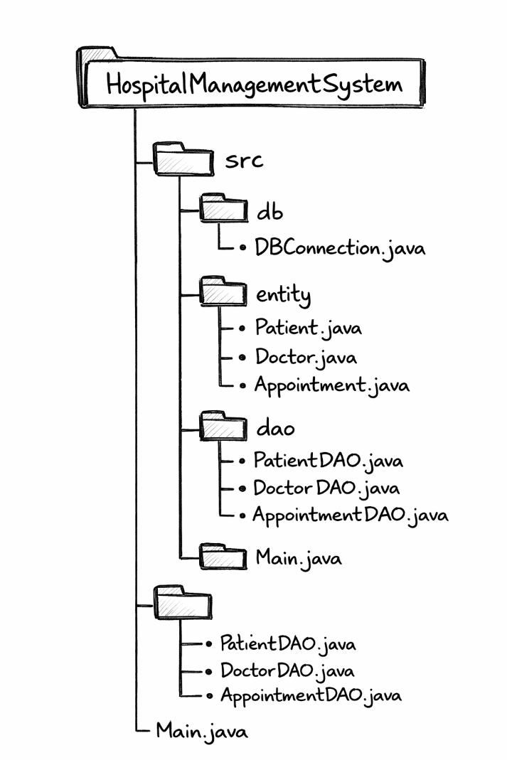

7. Database Design
7.1 Database Name
hospital_db

7.2 Tables Description
Patients Table
Column | Data Type | Description
id | SERIAL (PK) | Unique patient ID
name | VARCHAR | Patient name
age | INT | Patient age
gender | VARCHAR | Gender

Doctors Table
Column | Data Type | Description
id | SERIAL (PK) | Unique doctor ID
name | VARCHAR | Doctor name
specialization | VARCHAR | Medical specialization

Appointments Table
Column | Data Type | Description
id | SERIAL (PK) | Appointment ID
patient_id | INT (FK) | Patient reference
doctor_id | INT (FK) | Doctor reference
appointment_date | DATE | Appointment date

8. Module Description
8.1 DBConnection Module
Purpose:
Handles database connectivity using JDBC.
Responsibilities:
- Load PostgreSQL JDBC driver
- Establish secure DB connection
- Centralize DB configuration
Key Concepts Used:
- JDBC Driver
- DriverManager
- Exception handling

8.2 Entity Module
Entity classes represent real-world objects and map directly to database tables.
Patient Entity
- Holds patient details
- Encapsulates data using private fields and getters
Doctor Entity
- Represents doctor records
- Stores specialization details
Appointment Entity
- Stores foreign key references
- Uses java.sql.Date for DB compatibility

8.3 DAO Module (Data Access Layer)
The DAO layer handles all SQL operations, keeping database logic separate from business logic.
PatientDAO
- Add patient records
- Fetch all patients
DoctorDAO
- Add doctor records
- Fetch all doctors
AppointmentDAO
- Book appointments
- Enforces referential integrity via foreign keys
Best Practices Used:
- PreparedStatement (SQL Injection prevention)
- Try-with-resources
- SQLException handling

8.4 Main Module
Purpose:
Acts as the controller and user interface.
Responsibilities:
- Display menu
- Accept user input
- Call appropriate DAO methods
- Control application flow

9. Application Workflow
- User runs the application
- Menu options are displayed
- User selects an operation
- Input is collected via Scanner
- DAO performs database operation
- Result is displayed to user
- Menu repeats until exit

10. Key Java Concepts Used
- Object-Oriented Programming (OOP)
- Encapsulation
- Exception handling
- JDBC API
- Layered architecture
- DAO design pattern
- Try-with-resources

11. Error Handling Strategy
- Checked exceptions (SQLException) handled in DAO layer
- Runtime exceptions used for fatal DB connection errors
- Meaningful error messages displayed to user

12. Advantages of the System
- Reduces manual record handling
- Data persistence and consistency
- Modular and maintainable code
- Industry-relevant backend design
- Easy to extend to web applications

13. Limitations
- Console-based interface
- Single-user access
- No authentication
- No advanced reporting

14. Future Enhancements
- Add user authentication
- Convert to Spring Boot REST API
- Add GUI using JavaFX
- Implement transaction management
- Deploy using Docker and cloud services

15. Learning Outcomes
After completing this project, the developer gains:
- Strong understanding of JDBC
- Practical SQL integration experience
- Knowledge of backend system design
- Confidence in Java enterprise development
- Interview-ready project explanation

16. Conclusion
The Hospital Management System successfully demonstrates how Java can be used to build a real-world backend application using PostgreSQL and JDBC.
The project follows clean architecture principles, making it scalable, maintainable, and suitable for professional environments.

